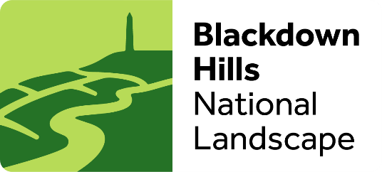

Blackdown Hills Access for All Grant 2025/26 Application form
The Blackdown Hills National Landscape has received Defra funding for capital spend to make our protected landscape more accessible to people of all ages and abilities and from all backgrounds. Please read the Access Grants Eligibility criteria notes below, before completing this form.
Email your Application to Hannah Metson at the Blackdown Hills National Landscape hannah.metson@devon.gov.uk

Contact name

Email address

Telephone number

Organisation name
If this is a collaborative project, specify who is leading and name key partners

Organisation address

Where will the work take place?

Please provide a project summary
(up to 250 words)
Please set out the key outcomes that the work will deliver and describe how the work will make the Blackdown Hills more accessible to people of all ages, abilities & backgrounds.
Please specify the main target audiences and beneficiaries.
(up to 500 words)
Please include measurable outputs.

Expected start date
(DD/MM/YYYY)

Expected completion date
(DD/MM/YYYY)

What are the costs of the project? Items above £5,000 must be supported by quote(s)

How much funding are you applying for?

If you have secured match funding what is the amount and who is supplying the funds?

Please note that funding is conditional on the following:
- Any planning permission or consents must be in place when you apply.

- The granted funded work MUST be delivered and paid for in 2025/26. All works must be complete and invoiced by 15th March 2026.
Eligibility criteria
The projects must be for capital spend. Capital spend is a one-off itemised cost where funding is provided to purchase or invest in a physical/digital item or asset to improve accessibility for all. Some examples of what would be classed as capital expenditure, include access infrastructure, buildings, machinery, and equipment, for example:

• Disabled toilet facilities
• Replacement of gates
• Additional seating areas
• Improved access to waterways for the mobility-impaired
• Widening and resurfacing of paths for multi-user use
• Purchase of trampers, mobility scooters, electric bikes, and storage/charging facilities
• Purchase of specially adapted tools and personal protective equipment for volunteers
• Provision of accessible signage and visitor information, physical and digital
• Creation of a new or improvement of an existing piece of access infrastructure, such as building a toilet or fitting a new accessible gate or adapting a minibus or visitor centre.
• Research and development, defined in budgeting guidance as:
“Creative work undertaken on a systematic basis to increase the stock of knowledge, and use of this stock of knowledge for the purpose of discovering or developing new products, including improved versions or qualities of existing products, or discovering new or more efficient processes of production”.

Some examples that are not classified as capital:

• Removal of a stile - unless it is being replaced by an accessible gate
• Hire of a minibus
• Staff time that is not directly attributable to creation of an asset

Key things to consider

• Consult with disability representatives for any planned works.
• Adopt a pan impairment approach and consider what the barriers to access are for all disabled people.
• Any accessibility infrastructure change or intervention should be accessible for all users, and, where possible to do so, should avoid the requirement of extra tools to use (for example, gates locked with RADAR keys) and consider safety, value for money and sustainability.
• Spend must improve public access to and within the protected landscape and should serve the broader interests of the Grant Recipient and their communities.

Funding

Funding for each project application should be between £2K – £20K but depending on the scale of work and the impact they will have, may be eligible for greater funding in exceptional circumstances

We encourage you to consider match funding for your proposal, either in kind or in cash, as this will be considered in the assessment of your application though we will consider 100% funding if the project is exceptional.

