**BLACKDOWN HILLS AONB**

**FARMING IN PROTECTED LANDSCAPES 2022/23**

**OTTERHEAD LAKES – NATURE TRAIL RESTORATION**

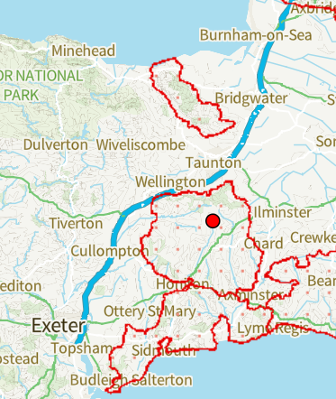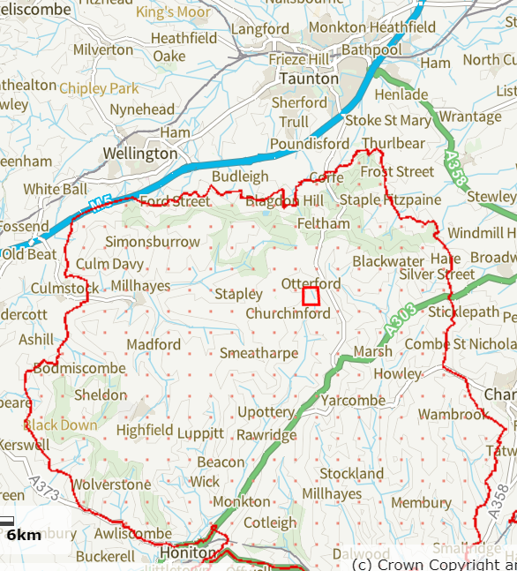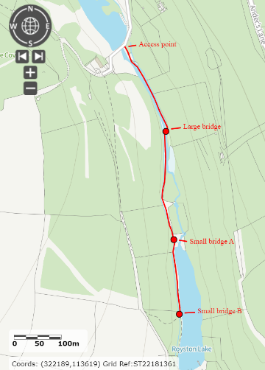

**Location within Blackdown Hills AONB, and trail plan at Otterhead Lakes Local Nature Reserve**

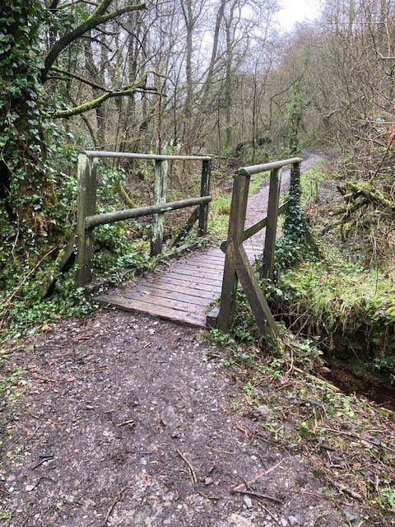

**Small footbridge before and after replacement**

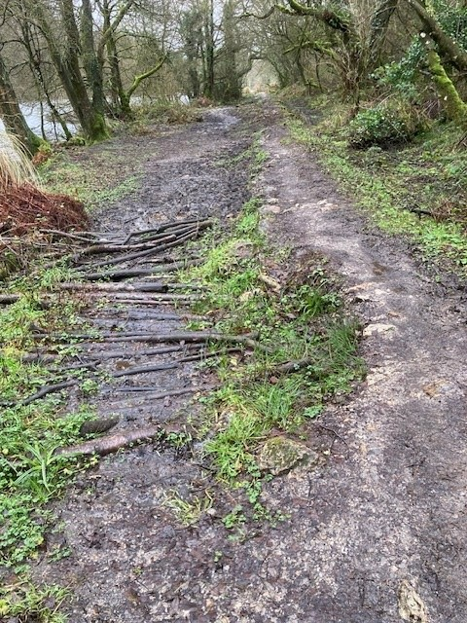 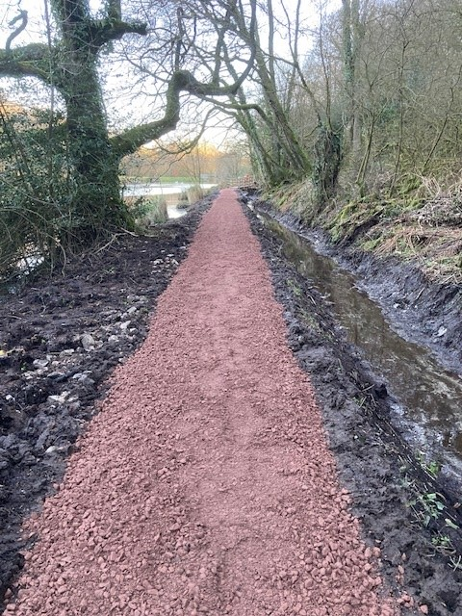

**Lake-side track before and after re-surfacing**

**Royston Lake footbridge before and after replacement**

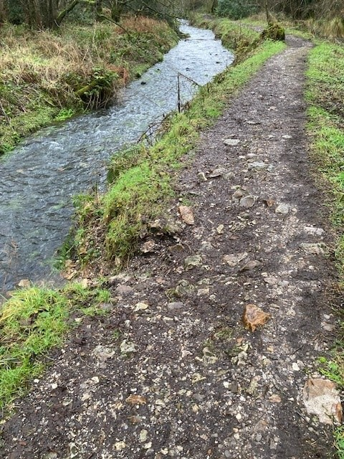

**Sections of the main trail before (above) and after (below) re-surfacing**

**Left - First vegetation and ditch clearance in progress; Right – chestnut pole bridge used for plant to cross river channel**

**Left – ditch reinstatement in progress; Right – stoning in progress**

**Lakeside trail section before and after re-surfacing**

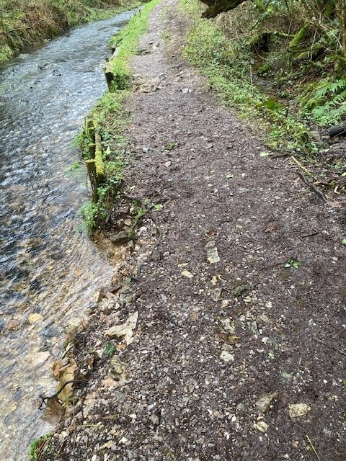

**Riverside sleeper edging before and during replacement**

**Completed new trail prior to re-opening**