BLACKDOWN HILLS AONB - 25 YEP FIPL CASE STUDY

GOREN FARM, STOCKLAND, NEAR HONITON
Goren Farm is a well-known supplier of high-quality wildflower seed across the South West and beyond, while its wildflower meadows provide an impressive local visitor attraction during the summer months. Julian Pady, who runs Goren Farm, approached the Blackdown Hills FiPL team to discuss ways of meeting the growing interest in wildflower meadows amongst buyers and visitors.

Demand for locally-sourced wildflower seed is beginning to overtake supply, and Goren Farm recognise that new ways are needed to meet this demand, beyond what the farm itself can supply from its own land. Increasing numbers of landowners are wishing to restore traditional meadow flora on parts of their land, and meanwhile there is also a need for existing flower-rich meadows and pastures to gain an economic value which can help pay for their management. Hence the demand for seed and the desire for economic return can be linked together, if seed from existing meadows can be harvested and made available to those who want it.

A project was therefore developed with the FiPL team which involved the purchase of a Brush Harvester, to be hosted and maintained by Goren Farm and made available on loan to local landowners to harvest seed from their own land. A Logic MSH420 Brush Harvester was been acquired which is a versatile, lightweight machine, towable behind a quad bike, ATV or small tractor, meaning it can be used on small sites with wet or uneven terrain. Goren Farm have been using brush harvesters for 15 years now but their own harvesters are tractor-mounted and too big for use on uneven and remote sites.
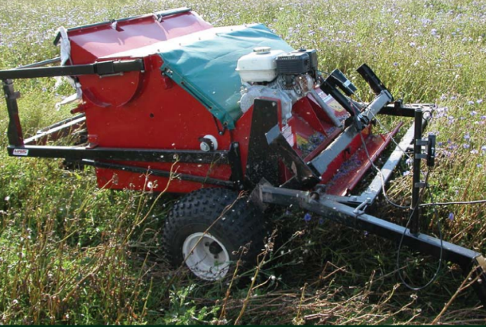
The harvester will be made available on a not-for-profit hire basis between competent operators in the local area. It is proposed that when the machine is needed, one of these operators will be able to use the harvester (with their own pulling machine) either for themselves or on behalf of another landowner. A small daily fee will be charged for transport, cleaning, greasing maintenance and replacement parts and insurance. Instruction will be provided to operators and they will be asked to sign a hire agreement. The harvester will reside at Goren Farm when not in use.

In addition the project funded the purchase of seed cleaning equipment, in the form of a Separator and set of Indented Cylinders, which will be used by Goren Farm to separate out seed of 8 key species from raw arisings gathered by the Brush Harvester, so that seed mixes can be designed to suit different soil types and conditions. The Separator is a specialised machine comprising a rotating drum in which different cylinders are inserted, each with indents on the inside surface of a particular size. Material is introduced into the drum and seed of the desired size becomes trapped in the indents, while larger material passes through. The process both separates out the target seed, and cleans out the chaff, stems and other debris.

Having this machine will enable Goren Farm to extend its services to others (allowing local landowners to bring their meadow arisings to the farm and extract key meadow-creation species), while also allowing Goren itself to offer more pure-seed or specific multi-seed mixes to its customers. The machine will hence have both a commercial value, and a community value by enabling others to make the most of their meadows.

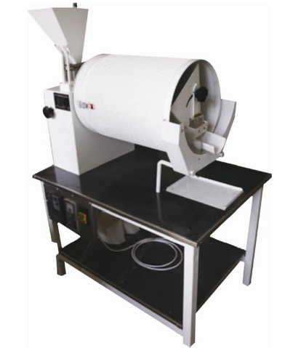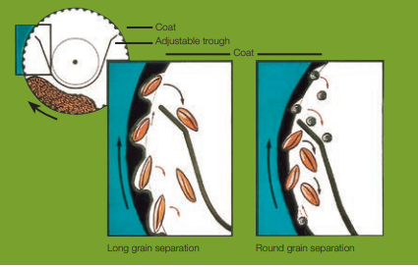

For the Brush Harvester, given this will be a community resource without specific commercial benefit a 100% grant was offered on a cost of £7095. For the Indented Cylinder Separator, a 50% grant was offered towards a total cost of £5858.

This investment by FiPL will provide a major boost to the ability of the Blackdown Hills landowning community to strengthen the local supply of wildflower seed to meet local demand. It will encourage collaborative working between landowners, while consolidating the role of Goren Farm as an exemplar in this field, supported by the AONB.

Gavin Saunders
FiPL Officer
Blackdown Hills AONB
May 2022

