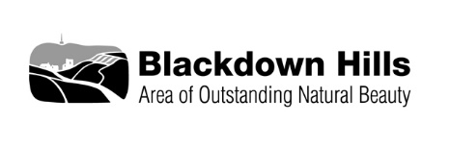
Blackdown Hills AONB
Sustainable Development Fund – Expression of Interest

If you would like to discuss your ideas for a SDF project with a member of the AONB team before sending a full application in please complete this form and send it to the email address below, a member of staff will then get back to you.

THIS IS NOT THE FULL APPLICATION FORM and will not be treated as a formal application.

Should you require further advice please call us on 01392 383600 or email blackdownhills@devon.gov.uk

Project Title
Name of Applicant
Name of Organisation
Contact Address
Phone no.
Email

Project Proposal (brief description of the idea, ideally including why it is needed, who it will benefit and how)

(no more than 500 words)

When will you be able to start and finish your project?

In which part of the AONB will you project happen?

Financial details
Overall project costs (if you do not have final figures at this stage please estimate the costs) | £
Potential amount required from this fund  (maximum 75% of project costs) | £

Once completed please send this form to:

Blackdown Hills AONB
Riverside
Hemyock
Devon
EX15 3SH
Or email blackdownhills@devon.gov.uk

